Experiment No 5
Roll No:24141030 Lab: PL-II

Theory

1. Introduction to Tuples
A tuple is an ordered, immutable (unchangeable) collection of elements enclosed in parentheses (). Once a tuple is created, its elements cannot be modified, added, or removed. Tuples are faster than lists and can be used as dictionary keys.
Example:
my_tuple = (10, 20, 30, "Hello", 3.14)

2. Characteristics of Tuples
Property | Description
Ordered | Elements maintain insertion order
Immutable | Cannot be changed after creation
Heterogeneous | Can contain different data types
Indexable | Access elements using index
Hashable | Can be used as dictionary keys (if all elements are hashable)

3. Creating Tuples
Method | Example
Empty tuple | t = ()
Single element (comma needed) | t = (5,)
Multiple elements | t = (1, 2, 3)
Without parentheses | t = 1, 2, 3
Using tuple() constructor | t = tuple([1, 2, 3])

4. Tuple Operations
Operation | Description | Example
count(x) | Counts occurrences of x | t.count(5)
index(x) | Returns index of first x | t.index(10)
len() | Returns length | len(t)
in | Membership check | 2 in t
+ | Concatenation | (1,2) + (3,4)
* | Repetition | (1,2) * 3

5. Tuple Packing and Unpacking
Packing: Assigning multiple values to a tuple.
Unpacking: Assigning tuple elements to multiple variables.

person = "Alice", 25, "Engineer" # Tuple of 3 elements
name, age, profession = person
print(name) # Alice
print(age) # 25
print(profession) # Engineer

6. Advantages of Tuples over Lists
Aspect | Tuple | List
Mutability | Immutable | Mutable
Speed | Faster | Slower
Memory | More memory efficient | Less memory efficient
Use as dict key | Yes | No
Data safety | Data cannot be changed | Data can be changed

7. Introduction to Sets
A set is an unordered, mutable collection of unique elements enclosed in curly braces {}. Sets do not allow duplicate elements and are optimized for membership testing and mathematical set operations.
Example:
my_set = {1, 2, 3, 4, 5}

8. Characteristics of Sets
Property | Description
Unordered | Elements have no specific order
Mutable | Can add or remove elements
Unique | No duplicate elements allowed
Heterogeneous | Can contain different data types
Unindexable | Cannot access by index (no indexing)

9. Creating Sets
Method | Example
Using curly braces | s = {1, 2, 3}
Using set() constructor | s = set([1, 2, 3])
Empty set (must use set()) | s = set()

10. Set Methods and Operations
Operation | Method | Operator
Union | A.union(B) | A | B
Intersection | A.intersection(B) | A & B
Difference | A.difference(B) | A - B
Symmetric Difference | A.symmetric_difference(B) | A ^ B
Add element | A.add(x) | -
Remove element | A.remove(x) | -
Discard element | A.discard(x) | -
Clear all | A.clear() | -
Check subset | A.issubset(B) | A <= B
Check superset | A.issuperset(B) | A >= B

Programs and Code:

1. Program to create a tuple and display its elements
my_tuple = (10, 20, 30, 40, 50)
print("Tuple:", my_tuple)
print("Elements:", end=" ")
for item in my_tuple:
print(item, end=" ")
print()
print(f"Type: {type(my_tuple)}")
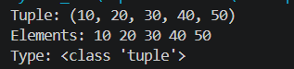

2. Program to find sum and average of tuple elements
my_tuple = (10, 20, 30, 40, 50)
total = sum(my_tuple)
average = total / len(my_tuple)
print(f"Tuple: {my_tuple}")
print(f"Sum: {total}")
print(f"Average: {average}")
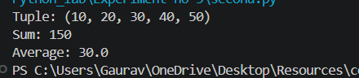
3. Program to find maximum and minimum in a tuple
my_tuple = tuple(map(int, input("Enter numbers separated by space: ").split()))
print(f"Tuple: {my_tuple}")
print(f"Maximum: {max(my_tuple)}")
print(f"Minimum: {min(my_tuple)}")
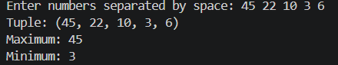
4. Program to demonstrate tuple packing and unpacking
print("=== Tuple Packing ===")
name, age, city = "Alice", 25, "New York"
person = name, age, city
print(f"Packed tuple: {person}")
print("\n=== Tuple Unpacking ===")
a, b, c = person
print(f"Unpacked: a={a}, b={b}, c={c}")
print("\n=== Swapping using tuple unpacking ===")
x, y = 10, 20
print(f"Before swap: x={x}, y={y}")
x, y = y, x
print(f"After swap: x={x}, y={y}")
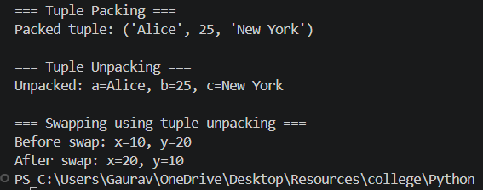
5. Program to convert tuple into list
my_tuple = (1, 2, 3, 4, 5)
print(f"Original tuple: {my_tuple}")
my_list = list(my_tuple)
print(f"Converted list: {my_list}")
my_list.append(6)
print(f"Modified list: {my_list}")
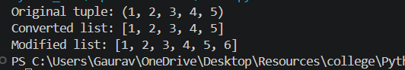
6. Program to create and perform set operations
set1 = {1, 2, 3, 4, 5}
set2 = {4, 5, 6, 7, 8}
print(f"Set 1: {set1}")
print(f"Set 2: {set2}")
set1.add(9)
print(f"After adding 9 to set1: {set1}")
set1.remove(9)
print(f"After removing 9: {set1}")
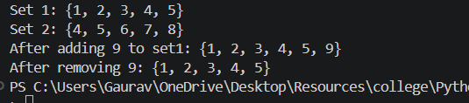
7. Program to find union, intersection and difference of sets
setA = {1, 2, 3, 4, 5}
setB = {4, 5, 6, 7, 8}
print(f"Set A: {setA}")
print(f"Set B: {setB}")
print(f"Union (A ∪ B): {setA.union(setB)}")
print(f"Intersection (A ∩ B): {setA.intersection(setB)}")
print(f"Difference (A - B): {setA.difference(setB)}")
print(f"Difference (B - A): {setB.difference(setA)}")
print(f"Symmetric Difference (A Δ B): {setA.symmetric_difference(setB)}")
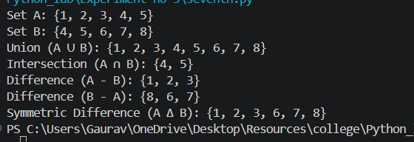
8. Program to remove duplicate elements using set
numbers = [int(x) for x in input("Enter numbers with duplicates: ").split()]
print(f"Original list: {numbers}")
unique = list(set(numbers))
print(f"List after removing duplicates: {unique}")
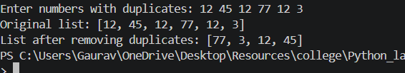
9. Program to check membership of an element in tuple
my_tuple = (10, 20, 30, 40, 50)
element = int(input("Enter element to check: "))
if element in my_tuple:
print(f"{element} is present in tuple at index {my_tuple.index(element)}")
else:
print(f"{element} is not present in tuple")
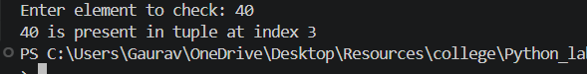

10. Program to count occurrences of an element in tuple
my_tuple = tuple(map(int, input("Enter numbers separated by space: ").split()))
element = int(input("Enter element to count: "))
count = my_tuple.count(element)
print(f"Tuple: {my_tuple}")
print(f"Element {element} appears {count} time(s)")
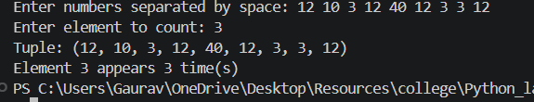

Conclusion
In this experiment, we studied tuples (immutable sequences) and sets (unordered collections of unique elements). We implemented tuple creation, sum/average, min/max, packing/unpacking, tuple-list conversion, set creation, set operations (union, intersection, difference, symmetric difference), duplicate removal, membership checking, and counting occurrences. Understanding these data structures is crucial for efficient data handling in Python.

